**New Builder Enquiry**

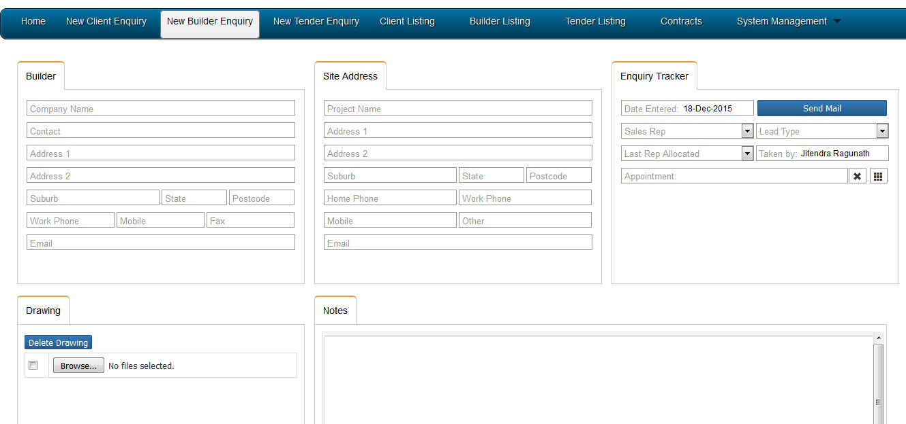

List of files that are used for this section

project_folder/includes/vic/enquiry/ new_builder_enquiry_vic.php

**List of tables used**

ver_chronoforms_data_builderpersonal_vic

**Any plugins we used**

(Basic Joomla CMS)

**List of business rules**

When we select suburb, the state and postcode automatically completes

**List of required fields**

Company name, suburb, state, postcode, work phone, email

Project name, site address, state, postcode, work phone, mobile, email

Sales representative, lead type, appointment date